Please sign the last sheet and return

Georgia Studies 2024 - 2025

Mrs. M. Eastman

Dear Families,

Welcome to an exciting year at A. R. Johnson Magnet School! I am thrilled to be teaching your child Georgia Studies this year. Under my instruction, your child can expect to master the 8th Grade Social Studies Georgia Standards of Excellence.

**Courses Overview**

In our 8th grade Georgia Studies course, we will explore the geography, history, government and economics of our great state of Georgia! Georgia has quite a rich history, making this course a very exciting and rewarding experience! In the spring, 8th grade students will be required to take the Georgia Milestones End of Grade Assessment.

**Units of Study**

We will be following the RCBOE curriculum units of study:

**1st Semester:**

Unit 1: Connecting Themes; Unit 2: Geography and Georgia’s Indigenous People; Unit 3: Exploration and Colonization; Unit 4: Statehood; Unit 5: The Civil War; Unit 6: The New South; Unit 7: The 20th Century

**2nd Semester:**

Unit 8: Post WWII Georgia; Unit 9: Civil Rights; Unit 10: Modern Georgia; Unit 11: State and Local Government; Unit 12: Adult and Juvenile Justice; Unit 13: Personal Finance

**Communication**

My main method of communication with parents will be through “Remind.” Please see the “Remind” handout for instructions on signing up. Remind code: @eastman24

I am also available through email: eastmma@BOE.richmond.k12.ga.us

**Supplies**

Students **must** bring all supplies to class daily. **Mandatory** supplies are:

* A composition notebook (college ruled, if possible) designated for GA Studies (no wire bound notebooks, please)
* A folder to organize and keep up with occasional hand outs.
* notebook paper (enough to last the entire school year) – please do not allow your child to pack a year’s supply of paper in his/her bookbag
* pencils or pens (blue or black ink for any assignments to be turned in; students may use other ink colors for their note-taking)
* glue sticks (preferred) or white glue
* colored pencils
* scissors
* earbuds or headphones
* 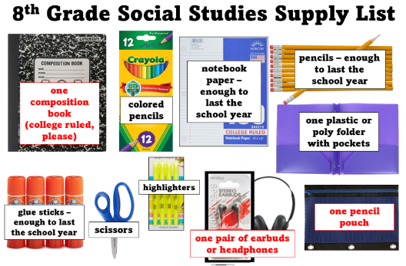highlighters
* one pencil pouch

**Optional, but not required:**

* pens of assorted color ink to enhance note taking
* index cards
* small pencil sharpener

**\*\*As students run out of supplies, please replenish as needed.**

**Grading**

Middle and High school student performance will be recorded and reported in all courses by numerical grades, based on a 100-point scale.

* Calculation of Final Grades Final grades will be determined by the cumulative semester average using the following criteria:

**Assignments will fall into one of the following categories:**

**Major Assignments – 40% of semester grade (tests, projects, performance tasks, etc.)**

**Minor Assignments – 60% of semester grade (classwork, quizzes, etc.)**

Tutoring is available as needed by appointment only. Please contact me if you are interested.

In accordance with RCBOE district policy, students are expected to submit assignments on time. Multiple incidents of late work may result in teacher-student-parent conferences to examine and correct the student’s work habits through an academic contract. Students in grades 6-12 may have their scores reduced by 5% per school day for a 25% maximum reduction (five school days). Late work submitted after the fifth school day will only be accepted at the teacher’s discretion. Completing work in a timely manner during the learning unit is essential for academic success.

**Relearn/Reassess**

Students who perform below 70% on a major assignment will be given the opportunity to relearn and reassess to show improvement in their mastery of the standard.

Students will submit a Relearning Plan as part of this process. This plan should include:

* Analysis of their errors or misconceptions on the previous major assignment.
* Complete assignments provided to relearn the content for mastery. Students may also attend a tutoring session.
* Complete and turn in any missing assignments.
* Commit to date(s) and time(s) to redo the assignment or retake the assessment.
* Share the plan with their parent and teacher for approval and signatures.

Upon satisfactory completion of the plan, as determined by the teacher, student should be given a minimum of one opportunity to be reassessed.

Teachers should have discretion to determine if R&R opportunities will be given for any minor assessment.

**Policies**

**NEW CELL PHONE POLICY IN THE 2024-2025 CODE OF STUDENT CONDUCT AND DISCIPLINE**

* Starting this year, cell phones and digital communications devices like Apple Watches and AirPods will be prohibited from our classrooms, hallways, and other communal areas from the time the morning bell rings to the time students are dismissed for the day.

**Behavior** that hinders another student’s learning will be dealt with according to the procedures outlined in Richmond County’s Code of Conduct.

The **dress code**, as outlined on pages 14-15 of the Student Code of Conduct will be strictly enforced. Prohibited items include, but are not limited to, jeans with holes above the knee, mini-skirts, sagging pants, bandanas, sweat bands, and leggings (unless covered by the appropriate length garment). Hoods and hats will not be worn inside the building. Students who refuse to comply will be in violation of Richmond County’s dress code policy and subject to discipline, as outlined in the Code of Conduct.

I look forward to working with each and every one of you!

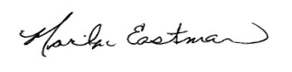Sincerely,

Marilyn Eastman - eastmma@rcboe.org

A.R. Johnson Magnet School (706) 823-6933

**I have read and agree to the terms of the syllabus.**

Student’s name _________________________________________________

Student’s signature ______________________________________________ Date ________________

Parent/Guardian’s signature _______________________________________ Date ________________